# Project Management Plan

## Scope management plan

### Project Requirement

### Project Functional Requirements

The accessing function:

-it should allow members of the gym to enter the gym using the app.

-it should not allow access for people who are not members.

-the system will record when the members entered and exited the gym.

The gym app:

-it will record the members progress.

-it will allow the members to see their progress.

-it should give tips to improve the experience.

-it will give access to the personal trainer to see the members progress.

### Project Non-Functional Requirements

1-opirational:

-the system should work with all phone brands.

-the system should record the progress of each member privately.

-the system should enable the members to share their gym info with their private trainer.

-the system should give new members access to the app.

2-preformance:

-The system should support all the gym members.

3-security:

-the members information can be only seen by the member himself and his personal trainer if he wishes.

-the times of entering and exiting the gym should be private to the staff.

### Priority Requirements

-it should allow members of the gym to enter the gym using the app.

-it should not allow access for people who are not members.

-the system should work with all phone brands.

-the members information can be only seen by the member himself and his personal trainer if he wishes.

### Scope Description (What)

|  |  |
| --- | --- |
|  |  |
| In scpoe | **Out Scope** |
|  |  |
| To hire a hardware installing team. | To install the hardware. |
| To hire a software developing team. | To develop the software. |
| To manage the work flow of the project. | To test the system. |
|  | To do a maintenance of the system every while. |
|  | To use the change in management plan. |

### Project Aim

1-to make a system that replaces the key cards accessing system.

2-to make an app that records the members progress.

3-to make a build in feature in the app to interact with a scanning device to give access to the gym members.

4-to make an app that gives the members progress to their trainers.

### Objectives (Why)

Your objectives should be covering all project aspects. For example: project productivity, stakeholder satisfaction and expectation, time and financial aspects.

|  |  |  |
| --- | --- | --- |
|  |  |  |
| project Objective | **project Benifit** | **Success metric** |
| The new system should at least reduce the number of key cards used from 300 keys to 25 keys in one year. | Reducing the use of plastic key card, therefor reducing the amount of waste, and helping the environment. | If the number of cards was reduced from 300 to 25 in a year |
| Increasing the number of members to at least 75 new members in a year. | More customers, more money, stakeholder’s satisfaction. | To get 75 new customers in a year |
| The app should at least give the member 3 useful information about their work out every day. | Customer satisfaction increase. | To give 3 quality points of information every day |

### Work Breakdown Structure (WBS)

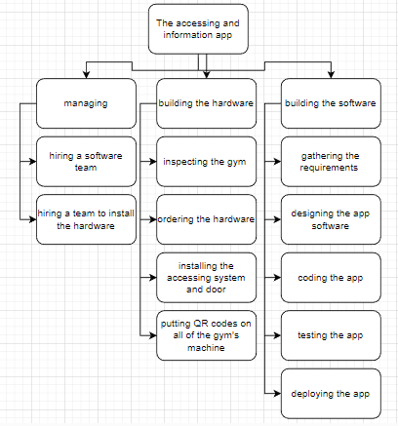

### Milestones

Milestones emphasize important events or accomplishments on projects.

|  |  |  |
| --- | --- | --- |
|  |  |  |
| Date | **Milestone** | **Description** |
| 20/1 | Milestone 1 | The hardware is installed |
| 8/2 | Milestone 2 | The app is ready and finished |

# Time, Cost, and Resources Management Plan

## Gannt Chart

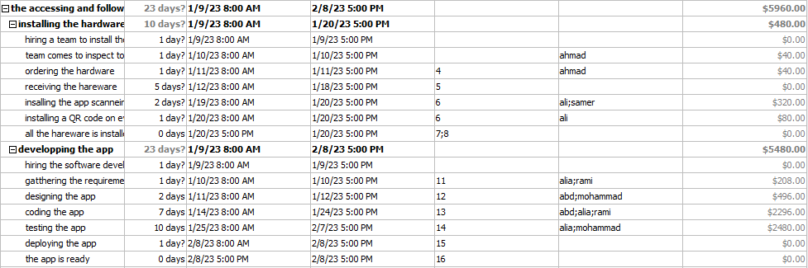

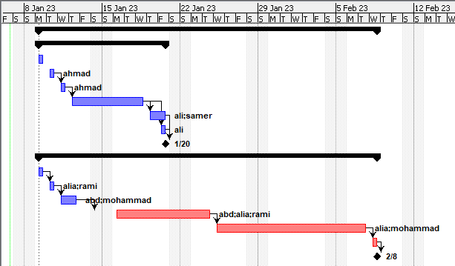

You need to discuss all parts of the Gant Chart and the relationship between them (time, cost, resources). Also, you are required to add the milestones of section 1.1.5 into the Gantt Chart.

## Critical Path Analysis

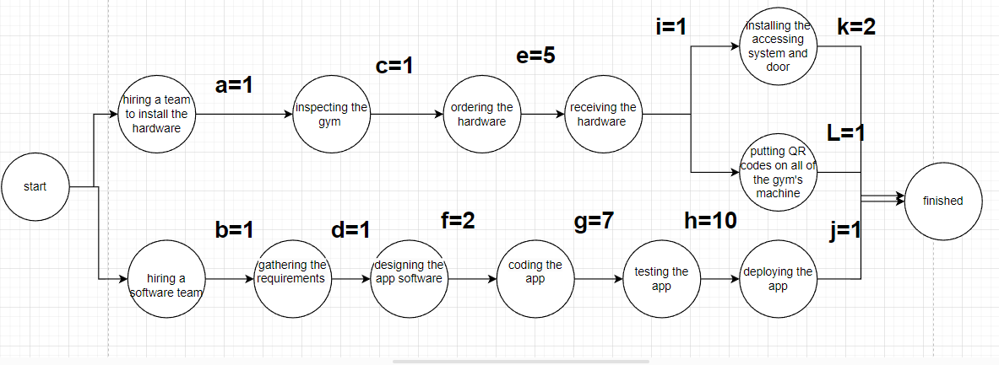

|  |  |  |
| --- | --- | --- |
| path | duration | Total duration |
| A+C+E+I+K | 1+1+5+1+2 | 10 |
| A+C+E+I+L | 1+1+5+1+1 | 9 |
| B+D+F+G+H+J | 1+1+2+7+10+1 | 22 |

The longest total duration of the critical path is the total time needed for the project, the longest path in duration can’t be delayed but any other path can be, unless it exceeded the duration of the longest path.

## Produce A Cost Estimate (Budget)

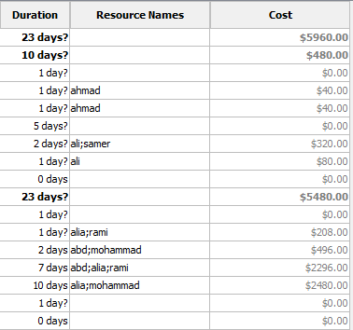

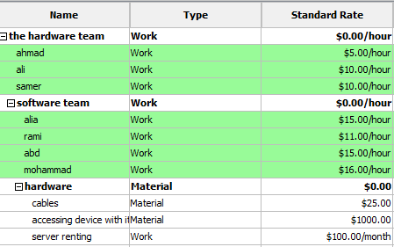

## Change Management Plan

First, assess who and what will be affected by the change.

Second, prepare a strategy in three phases: Awareness, Readiness, and Resilience to ensure the positive reception of the change.

The gym members are going to be affected by the new system, also the trainers may feel the change as they will have to see the members progress on the phone and five them feedback

## Awareness

The trainers have to go through a meeting that explains the change, and for the members signs are going to be all over the gym talking about the change and their going to be a document that is going to talk about the new system

## Readiness

The trainers have to go through a training lectures about the new system, for the members there are going to be a video explaining how the system works send to them by email.

## Resilience

The app is going to have a tutorial when they first log into it and there is going to be a video playing beside the access door talking about the access door and how it works and the receptionist is going to be told to help members that are confused.

Third, list what kind of measures you plan to determine if the change adoption was successful. Such measures may include surveys, usage metrics, and feedback sessions.

a customer satisfaction device is going to be placed beside the door to see if they like the new system and an online survey is going to be sent via email.

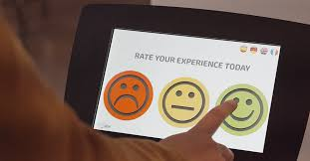

## Risk Management Plan

### Risk Types

|  |  |  |  |
| --- | --- | --- | --- |
| Risk Type | Risk name | Scenario | Mitigation Plan |
| The hardware got delayed | R1 | The hardware got delayed in the Jordanian customs | Accept the risk because it is not important to finish the hardware installing before the software is done because it is not the most critical path |
| The app has some bugs | R2 | The app was not tested carefully so some bugs was not detected | The team has to fix those bugs and continue testing |
| The scanning device is shutting off some times | R3 | There is a lose wire that keep touching the frame and restarts the system | The hardware team has to check on the accessing device |
| The trainers are not checking the information they get | R4 | The are not used to train using the app | Giving them practice lessons |
| Some people are concerned about were their information goes | R5 | Members think that other members can see their progress and information | Insuring to them that only the trainer can see the info if the members want that |

### Probability chart:

|  |  |  |  |
| --- | --- | --- | --- |
|  | **Probability** | | |
|  | **Risk name** | **Qualitative** | **Quantitative (if measurable)** |
| **Low** | R1 |  |  |
| R5 |  |  |
| R3 |  |  |
| **Medium** |  |  |  |
| R2 |  |  |
| R4 |  |  |
| **High** |  |  |  |
|  |  |  |
|  |  |  |

### Impact chart:

|  |  |  |
| --- | --- | --- |
| **Impact** | | |
|  | **Risk name** | **Impact Description** |
| **Low** | R1 | because it is not important to finish the hardware installing before the software is done because it is not the most critical path, so it is harmless |
| R5 | If they are not convinced that it is secure they might not use the app reducing the customer satisfaction. |
|  |  |
| **Medium** | R3 | It might be an inconvenience but the receptionist can give them access to the gym instead. |
| R4 | Members might think that this future is not working and would not use it any more reducing the customer satisfaction. |
|  |  |
| **High** | R2 | It may cause a lot of problems such as it can allow unmembers to enter the gym, it might give the members info to some one else than their trainers and so on. |
|  |  |
|  |  |

### Probability and Impact Matrix:

|  |  |  |  |  |
| --- | --- | --- | --- | --- |
| **Probability/Impact Matrix** | | | | |
|  | | **Impact** | | |
| **Low** | **Medium** | **High** |
| **Probability** | **High** |  |  |  |
| **Medium** |  | R4 | R2 |
| **Low** | R1, R5 | R3 |  |

## Software development methodology

You need to justify your selection for the project management methodology (e.g., Waterfall, Agile, Rapid Application Development (RAD).

I used the water fall method because this system has been used a lot so the recrements are clear and the steps are clear, and the water fall is only good for big projects but the team number is big compared to the task they have to do.

**Part 2:**

**(2.1)**

There are a lot of methods and mediums that can be used to communicate with various stakeholders, each of them has its own advantages and disadvantages that determines which one is better to use in a specific situation.

Like when talking to a manager or the owner of the organization you should use a presentation to present your goals, your ideas, the procedures, and what are the benefits of the project, so when using a presentation, you can give them a clear idea of what to expect.

During the project you have to connect with the managers for a question, a change in the plan, a problem and to do that you have to meet with him either in person or online and that depends on if the managers is available (if he can pe present in the place or if he has time to do so).

To order supplies you have to communicate with the supplier and that is usually done by writing massages between each other’s and that can be called a written document.

To alarm the customers that there is a change that is about to happen and a new accessing system is being made written documents are going to be all over the gym, and the videos that has to be sent to explain the system to them is a type of documentation.

If the project research can give information that was not known and they would have other wise needed to ask a stake holder about it in a meeting, the meeting is now not needed and they could communicate using emails(doc’s).

Other thing that can change the method of connection is the audience, like if the audience is very important, they can’t do an online meeting and they have to do a face to face meeting.

**2.3 Present arguments for the planning decisions made when developing the project plans. Arguments should include justifications for key points from cost estimate analysis, deliverables, success metrics.**

The cost estimate is important to determine the project budget and it divides the cost for each task separately which makes it easy to track how and where did the money go, and it gives the organization an idea of the price of the resources needed, and it predicts the prices for hiring teams to work on the project, it also can also reduce the risk of the project being over the budget for the company.

The deliverables of the project has to be clear for the company and for the project manager to set up the expectations of what is the end result of the project going to be like, and they are the things that the project has to work forward to achieve, ant they also keep the project on track by working under guidelines such as time and measures .

The success metric is important because it determine the success of a project. Also, they can help the managers of the project to evaluate the project’s progress and the productivity of the team and compare it with the completion dates to check if they are going with the plan, they also keep the project members motivated to work so they can reach the metric.

**2.4 Assess the extent to which the project recommendations meet the needs of the identified organization, including fully supported rationales for planning decisions made. Your assessment may include how the recommended budget, timeline, risks, resources, and change management plan meet the needs of the organization.**

The organization needs to know the estimated budget to see if the new system is going to be economically be justifiable if it reduces some costs or if it would get more customers, simply to see is the project cost is going to benefit the organization economically or in other way that it is logically good to make the project and to check if the revenue they would get from the project will cover the investments and when it is going to.

The organization would need to know the time line of the project to get an expectation on when the project going to end and to track if the project is doing well on time or not to prepare for the change that is going to happen from the project.

The organization would need to know the risks of the project to help them think of mitigation or way to avoid those risks so if any of them happen they have already thought of the ways to solve that risk, or it might be because they need to keep in mind the impact of the risks so if it happens they don’t blame the project managers and would justify the impact it made.

The organization would want to know the project resources to see if they got utilized by the project and to give a justification on where did a part of the budget go and to provide any unavailable resources that the organization does not have and is important for the project.

The organization would want to know the change management plan to know what their customer and their staff would go through, and to prepare for any new challenges they could face to make the change as smooth as possible s ono one get harmed or lost in the process.

**PART3:**

(3.1)

The reliability of the data means that the data has to consistent every time you make the research, in simple terms it means to what extent would the result of the research be similar if the research was done again in the exact same circumstances.

There are three types of data reliability:

-test-retest: does the same results appear when the tests are redone.

-interrater: does the same results appear when you do the test on other people.

-internal consistency: does the same results appear from two different tests designed to test the same thing.

The validity of the data means to what extent did that data they measured is the data they asked for, and for that the data has to be formatted correctly so no unrelated data is used, it can also mean that the data is similar to.

* Reliable data is not always valid.
* Valid data can be reliable if it is accurate and can be reproduced.

When using the qualitative research methodology, the results gathered can vary a lot from a person to person so the data is not reliable but, it is accurate because the questions asked can go from general to specific forcing the one interviewed to give the important details for the research.

But when using the quantitative research methodology, the data will be mostly reliable but may not be accurate because it is more general.

In my research the quantitative research was more suitable because the research did not need detailed information and the time for the research was short.